EE/CprE/SE 491 WEEKLY REPORT 3
10/08/25 – 10/14/25
Group number: 36
Project title: Secure Wireless Aircraft Data Load
Client &/Advisor: Daniel Riechers and Mohammed Selim
Team Members/Role:
Anish Nag
Gurumanie Singh
Lincoln Hatlestad
Declan Creadon
Justin Rohde
Doyle Chism
(All the above information should be there in each weekly report. The format/color scheme etc need not be the same. However, please remove everything that is in a bracket from your final submission. These are just part of the template and need not be a part of the report.)
o Weekly Summary (Short summary about what the group did for the week. This should be about a paragraph in length. These are just a few questions to help you get started. What was the overall objective for the week? In general, what tasks were completed? Were there any changes made to the project?)
The main objective of this past week was to conduct research on various ARINC standards and then get more information from our client advisor on what this project is trying to accomplish. Before our meeting with the client advisor, the group conducted research on ARINC 665, 645, 615A, and 429 to gather more information on what standards we need to abide by in order to develop a complete solution. Additional research was done on the possibility of using TFTP as our communication protocol along with how we will implement EAP-TLS into our solution. Following this research, we went to our meeting with the advisor and were able to gather more information on what exactly the scope of the project is. The advisor was able to provide us with a general schematic and give us more of an overview on the technical details such as distance, size, etc. Lastly, we are discussing what Raspberry Pi’s we should buy for the project and also how much storage we will need for each Pi.
o Past week accomplishments (Please describe/summarize as to what was done, by whom, when and, collectively as a group. This should be about a paragraph or two in length. Bulleted points are acceptable as well. Please keep only your technical details related to your project. Figures, schematics, flow diagrams, pseudocode, and project related results are acceptable, but please ensure that they are legible (clear enough to read) and to provide an explanation. If researching a topic, please add a few details about what was learned and how it is relevant to the project. If two or more people worked on a single task, be sure to distinguish how each member contributed to the task. Specific details relating to the assistance provided to other members may be included here. Do not include classwork, such as individual reflection assignments, and group meetings as part of your duties.)
- Declan Creadon: Researched what Raspberry Pi configuration would be best to start with. Tried to get a better understanding of what we are actually doing and what communication protocols will be in place.
- Doyle Chism: I researched which Raspberry Pi we should use and what would be the best performance for our project. I learned that we should use 8GB processing speed for this project, and moving forward, we can begin to configure the Pi’s with this implementation.
- Gurumanie Singh: Looked into figuring out the best add ons needed for the Raspberry Pi based on what the client mentioned over the past week. Additionally, also looked into the various ways to implement EAP-TLS within our project with the updated diagram that was provided by the client.
- Justin Rohde: Built and configured 2 raspberry pi virtual machines on VMWare workstation. On these VMs, I built a basic TLS infrastructure and tested it across the machines. Built diagrams of the EAP-TLS solution.
- Anish Nag: Test wifi security implementations such as wpa3 on personal raspberry pi zero 2 w that has a wifi chip that allows for networkmanager configurations.
- Lincoln Hatlestad: Cloned and installed vcpkg into my branch of the open source library. I continue to have build errors. Updated our solution design to overlap with the schematic Daniel presented to us.
o Pending issues (If applicable: Were there any unexpected complications? Please elaborate.)
- Declan Creadon: Additional information on what exactly we are connecting to. An access point was mentioned, but not much past that.
- Lincoln Hatlestad: I continue to have issues running the open source software required for our project. Using CMake to build the project has been a large issue and the testing documentation is lacking in information regarding build issues.
- Justin Rohde: Never worked with containers before, I need to research about them.
- Gurumanie Singh: Some complications emerged regarding the plausibility of implementing EAP-TLS within the Raspberry Pi using Dockerized containers/Virtual machines. Still working on figuring out which would work best and how to split up the tasks of the Supplicant, Authenticator and Server within the number of Raspberry Pis.
- Doyle Chism: I am still experiencing issues with the exact implementation of EAP-TLS and ARINC615A security clearances. Since we have not received our Pis yet, it is hard to know exactly how these should be configured and utilized for data transferring.
∙ …
o Individual contributions (Creating this section is optional, but it is Required to include the “Hours Worked for the Week” and their “Total Cumulative Hours” for the project for each member somewhere relevant in your report. Your individual weekly hours should be at a minimum of 6-8 hours for this course. So please manage your time well. Also, ensure that individual contributions support your claim to the weekly hours. Be honest with the reports.)
NAME | Individual Contributions  (Quick list of contributions. This should be short.) | Hours this  week | HOURS  cumulative
Declan Creadon | - Researched how we will have the Pi’s communicate  - Researched Pi Configurations | 2 | 16
Lincoln Hatlestad | - Cloned vcpkg into my branch of the ARINC 615A library | 1 | 16.5
Gurumanie Singh | - Worked on figuring out how to implement the EAP-TLS within our Raspberry Pi  - Add ons that are necessary for our Raspberry Pi | 2 | 17
Doyle Chism | - Researched Pi 5s and which one is best for our project  - Researched the performance of RaspberryPi 5. | 2 | 18
Justin Rohde | - Built and configured 2 raspberry pi virtual machines on VMWare workstation  - On these VMs, I built a basic TLS infrastructure and tested it across the machines.  - Researched about typical flight entertainment data load sizes | 4 | 22
Anish | - Implemented wpa3 security on raspberry pi zero 2 w | 3 | 25

o Comments and extended discussion (Optional)
In our meeting with Daniel last week, we discovered that we had some very large gaps in our project background knowledge. We previously thought our device would be loading the data completely wirelessly from outside the plane. Daniel illustrated for us though, that the product should be something a technician can use inside the plane to load data wirelessly to the multiple systems within. Thankfully this didn’t change our design much, as our simulated environment works for that scenario as well(e.g. We didn’t have to change our network setup or the number of Pi’s).
o Plans for the upcoming week (Please describe duties for the upcoming week for each member. What is(are) the task(s)?, Who will contribute to it? Be as concise as possible.)
- Declan Creadon: Research what security standards we will need to have in place. For example, do we need to follow NIST 2.0, etc. Additional research on TFTP and EAP-TLS.
- Lincoln Hatlestad: Run and test the open source ARINC 615A library that we will be building the rest of our software on. We assume it has all the functionality we need, but need to confirm that. As someone on the software side of this project, I also need to start designing the frontend components of this project, and diagram how it connects with the firmware and hardware.
- Gurumanie Singh: Start working on testing if Dockerized Containers or Virtual Machines on our Raspberry Pi would be the best approach moving forward.
- Doyle Chism: Order Raspberry Pi’s and verify with Professor Selim if our implementation is correct, so once we receive the Pi’s, we can start configuring them.
- Justin Rohde: Continue testing configurations and solutions with the raspberry pi virtual machines. Our best solution would be to have 2 pis, one being the loader, one being the supplicant. On the supplicant we have two dockerized containers, one being the RADIUS server, the other being the Auth server.
- Anish Nag: Implement another security measure that is non-wifi related. Testing with a sample payload and trying a MitM attack to see the packet in transfer would be a good way to get an attackers perspective on extracting the payload that is in the network packet.
o Summary of weekly advisor meeting (If applicable/optional)
(Provide a concise summary on the contents and progress made during the advisor meeting.)
- We presented our research on the ARINC standards and open source libraries.
- Daniel walked us through the domains of this project(ACD, AISD, PIESD, Open Domain) and their
- We asked questions about our project requirements, scope, and use.
- The schematic shown below was drawn by our client advisor to give us a better idea of what we are trying to accomplish.
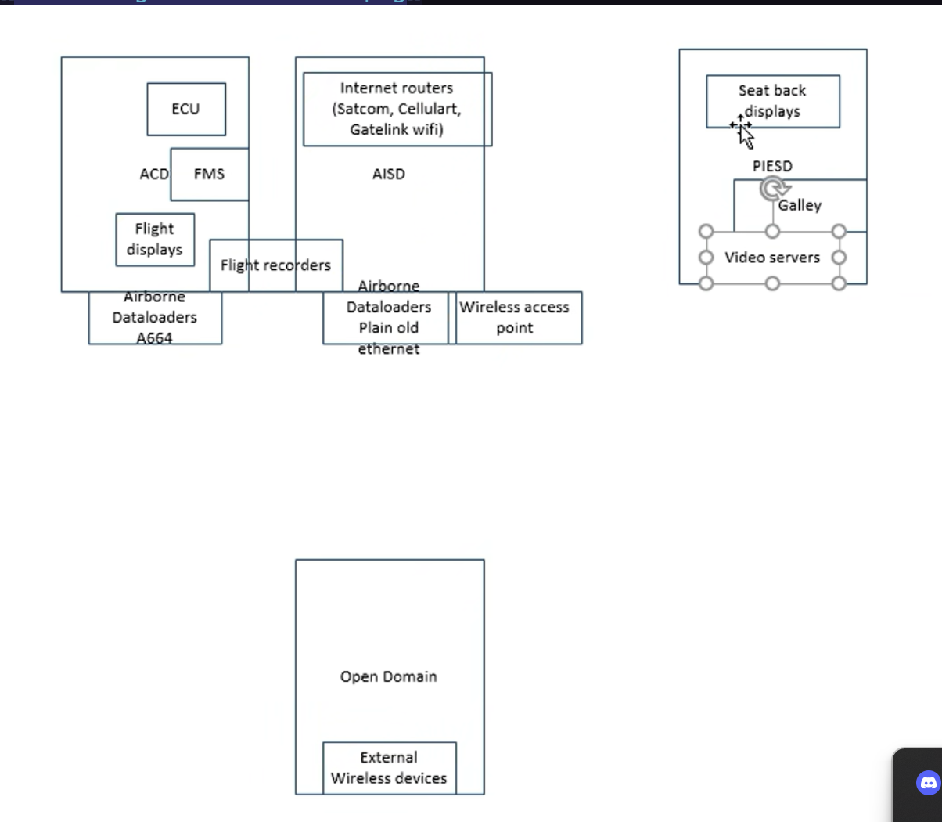

- In general, all of our communication between the Raspberry Pi’s is going to be within the airplane so distance should not be an issue anymore. We are going to be transferring media files from one Pi to the other so data sizes are going to be large. Lastly, we just need to order our Raspberry Pi’s.

